|  |
| --- |
| FAST National University |
| **Lab 5** |
|  |

**Computer Organization and Assembly Language**

|  |  |
| --- | --- |
| **Student Name** | Umamah Hussain |
| **Roll Number** | 21L-1858 |
| **Instructor** | Hazoor Ahmad |
| **Class** | CS3 |
| **Section** | A1 |
| **Semester** | Fall 2022 |

Fast School of Computing

FAST-NU, Lahore, Pakistan

# Activity 1:

## **Assembly Language Code**

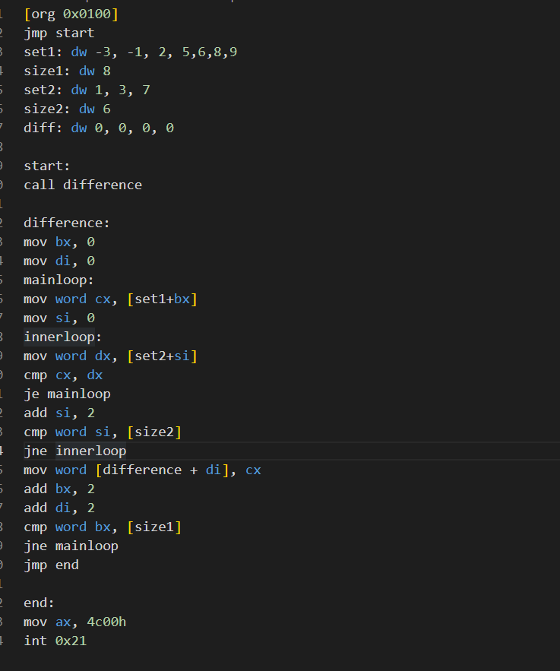int 0x21

## **Debugging Screenshots**

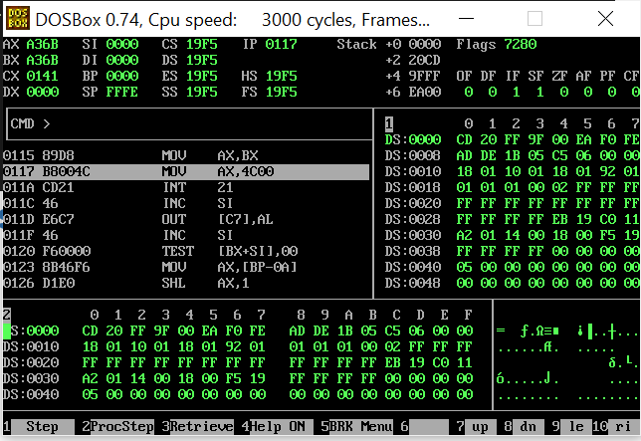

# Activity 2

## **Assembly Language Code**

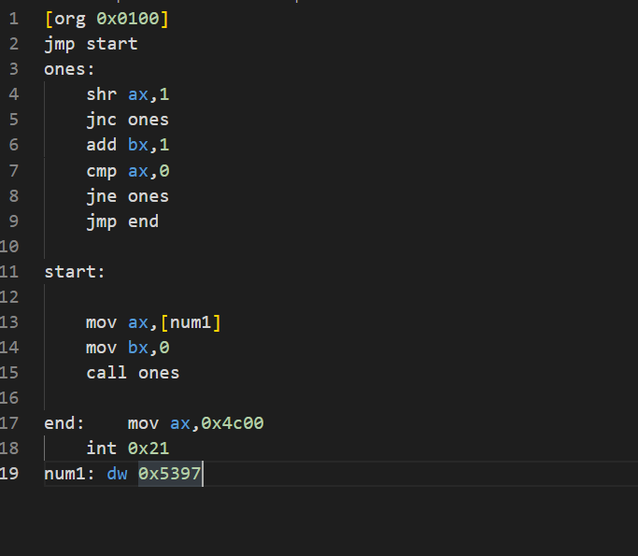

## **Debugging Screenshots**

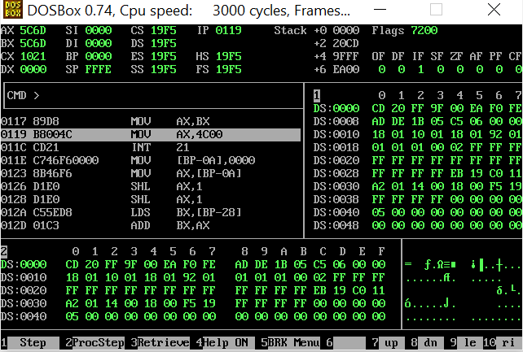

# Activity 3:

## **Assembly Language Code**

## **Debugging Screenshots**

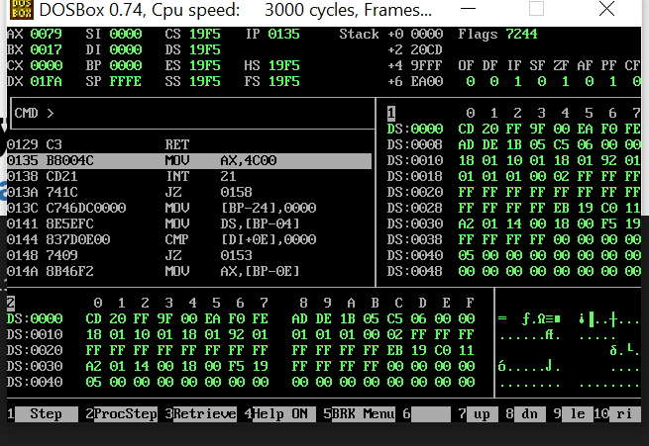

# Activity 4

## **Assembly Language Code**

## **Debugging Screenshots**

